**In Search of a Soft-Shell / Carapace Hardness / Meat Content Measurement Device:**

|  |  |  |
| --- | --- | --- |
|  |  | Alaska Shellfish Growth Research | NOAA Fisheries |
| Male snow crab have very long legs and are much larger than females (not shown). |  | **Snow crab moulting**: A soft-shelled crab is shown emerging (left) from its old, hard shell (right). Note the larger size of the soft-shelled crab. |

|  |  |  |
| --- | --- | --- |
| Snow crab fishery expects early season will protect right whales, improve  catch | CBC News |  |  |
| A catch of snow crab being landed at port. About 50 to 100 million snow crab are caught each year in the New Brunswick and PEI and Quebec. Only male snow crab are caught. |  |  |

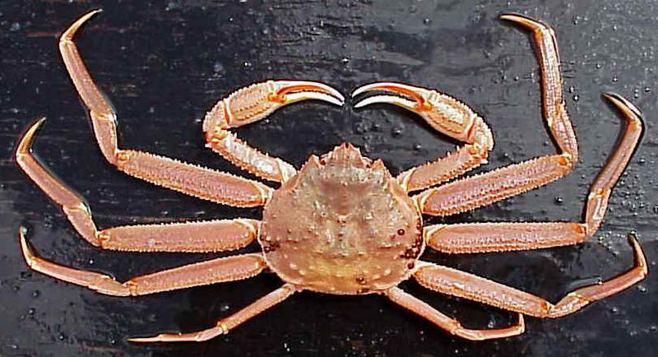 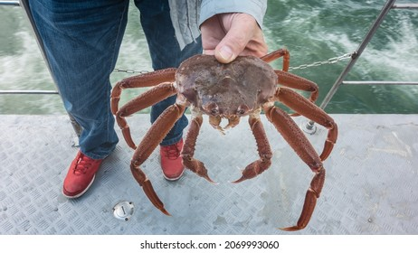

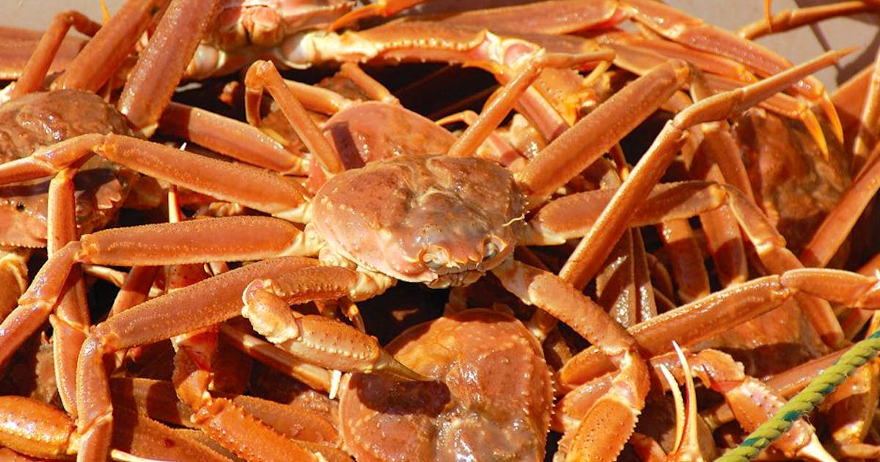

**Background:**

* Snow crab grow through a process called moulting. where animal’s old, hard carapace is shed and a new, soft one is formed and gradually hardens at a larger size.
* Important to distinguish between these new moults, which represent new arrivals to the commercial stock, and the un-moulted (harder-shelled) crab that is left over after the fishery.
* The identification of soft-shells allows for a partitioning of the commercial stock into new recruits (arrivals) and residual portions (left-over after the fishery).
* Historically, these states are identified using carapace condition : a classification scale from 1 to 5, based on a number of subjective evaluation of several external criteria such as colour, iridescence, epibionts and shell hardness.
* The proper application of this scale requires much training and calibration of field samplers to insure that observations are consistent between field samplers, with varying success.
* Further complicating things is the fact that the external appearance of crab varying between different locations and over time, creating much uncertainty as to the reliability of these observations.
* Soft-shelled crab also pose a problem for the fishing industry and managers, as they are less desirable in terms of market value, due to their low meat content, but are likely to suffer mortality even when returned to the sea.
* As such, a soft-shell protection protocol, using third-party observers on board the fishing vessels, is currently applied which closes areas with high proportions of soft-shelled crab during the fishery.
* However, the identification of soft-shelled crab by observers has been plagued by uncertainty and bias, due to lack of proper training, data quality control, and general incompetence in recent years.

Thus there is a need by DFO Science and at-sea observer companies to standardize the evaluation of carapace condition and make it more objective.

There is a close association between soft-shelled and meat content that is also of interest for shellfish processors,

DFO support:

* Biological and statistical analysis, field testing, implementation and contact with at-sea observer companies.
* Options:
  + Optical / Mechanical / Acoustic material properties
  + Robust / Small / Cheap device / Idiot Proof
  + Applications for DFO / Fishing industry:
    - Objective identification of newly moulted crab
    - Application to snow crab soft-shell protection protocol – at-sea observer monitoring of snow crab catches.

Future developments: Quick estimation of meat content (buyers and seafood processors).